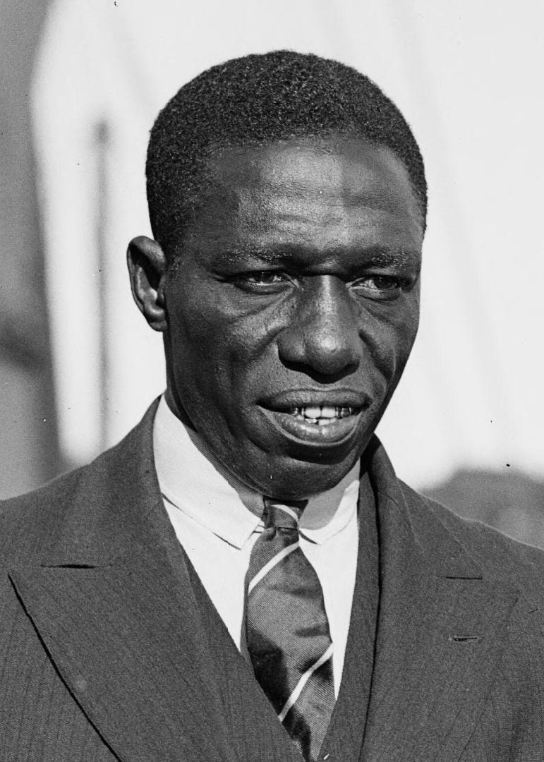

Name: Barack Obama

Age: 35

Email: [baraak@outlook.com](mailto:joeb@usa.com)

Cloud Computing

Skills: docker , kubernetes , azure ,

aws , virtualization